Analytical workspace designer – Formation

Data model and design consideration
- Mostly fix, we have a lot of fixed engine in the FW
- In AIH, many alternative paths, there are different context.
- When designing, start with MVP, take smth small, to be able to adjust the design.
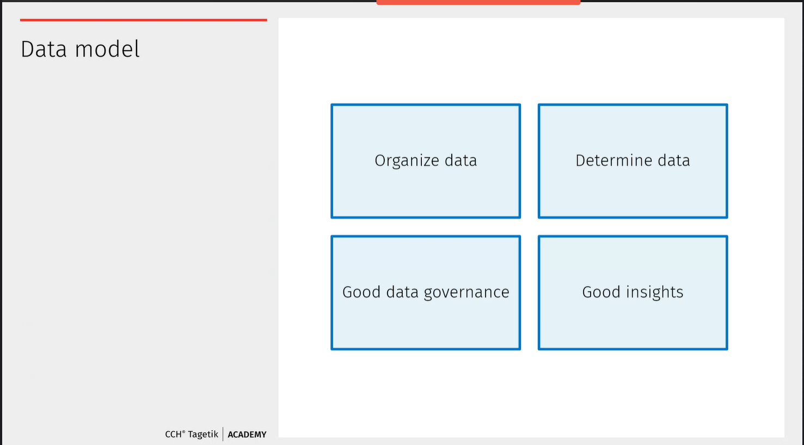

- We need to make that our source are correct and properly maintained, to have a good data insight.
- Most of the data model, are the dimensions.
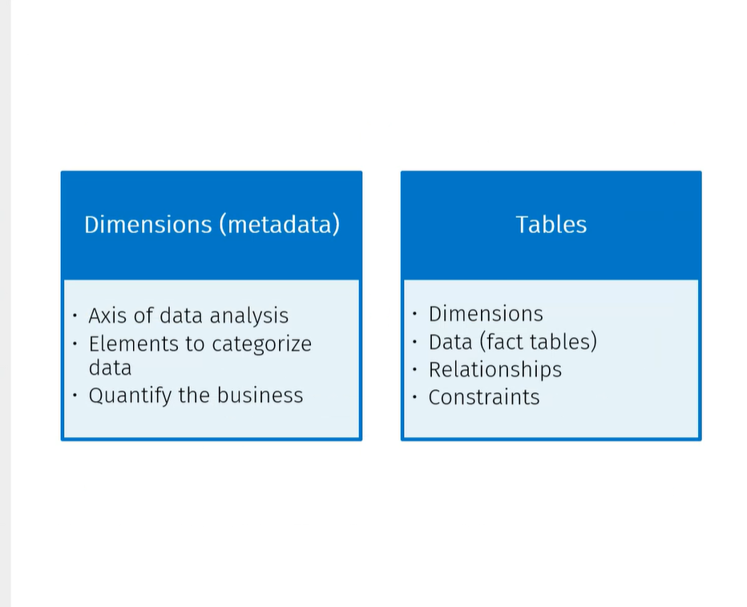

- The data model design is affected by the business rules and customer needs.
- The source of information are managers, users, reports documentation.
  - Mostly users than managers .
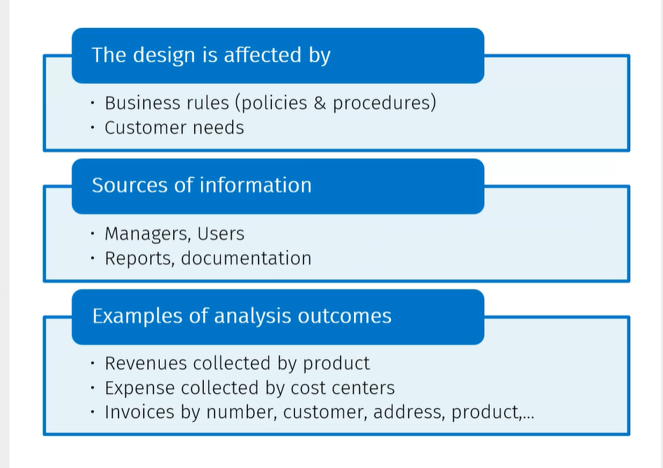

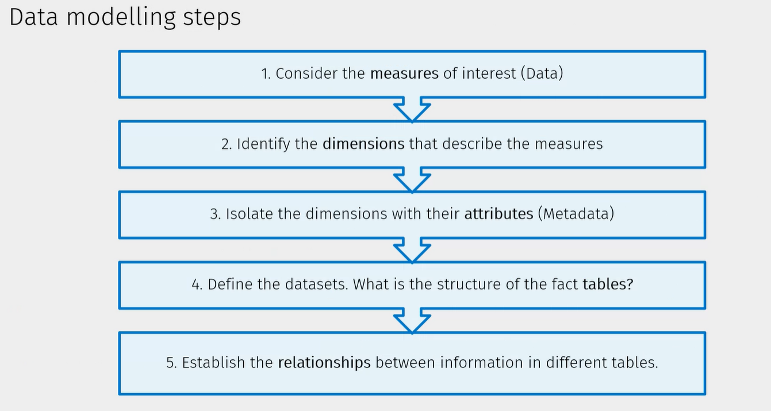
- Mesure of interests : What is the data points that you need.
  - Then the dimensions should rall from that, have the dimensions that describe the attributes.
  - Then define the datasets structure
  - Establish the source information and table relationships.

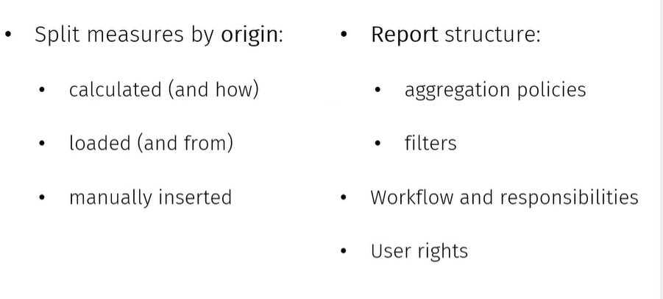
Best practice:
- Where are the measures from which sources
  - Depends, on the amounts of data that you have to calculate.
  - The amount of tables and rows that you are using.
- Report Structure :
  - What are the aggregation, what are the workflow, .. all these factors are important.
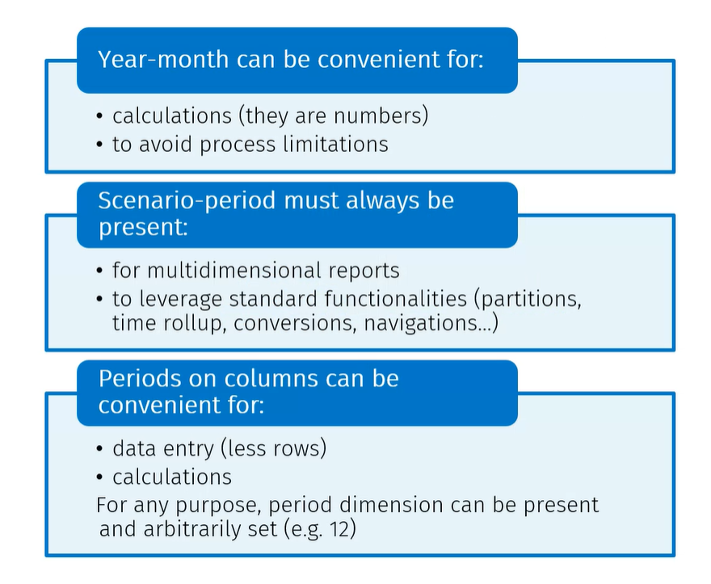
- You need the scenario and period in the dataset, the moment youneed to report in a multidimensional way.
- The partitioning is here important
- Period on columns can be convenients for : Data entry or calculations
Account dimensions:
- The account, avoid having limitation in process and form: 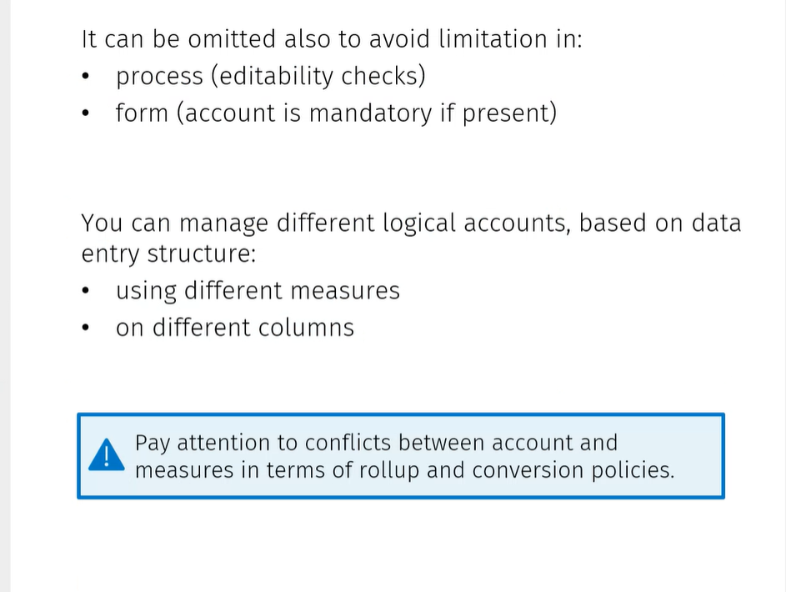¸
- If we want to combine account dimensions and the measure, make sure that the roll up and conversion are the same.
Entity Dimensions :
- IT drives the portioning policu by business cycle &Entity
- It is used to generate calculation layer partition when DTP is run from con

Currency :
- Best to make transaction in the AIH and convert in AIH
- 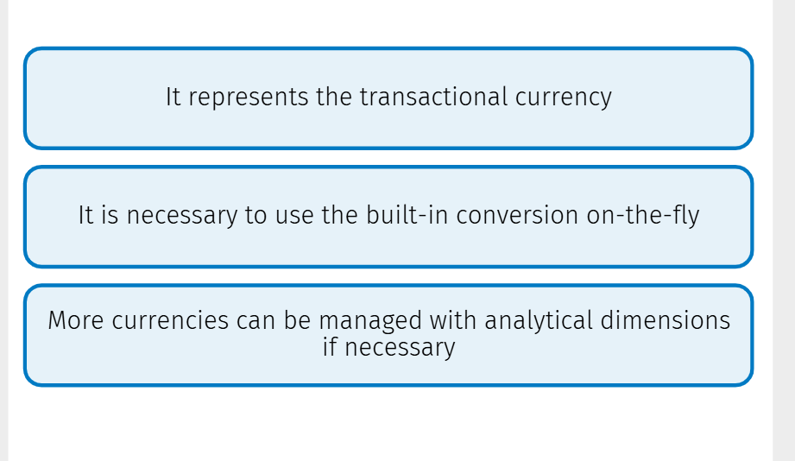
Category dimension is useful when you have the allocation or consolidartion
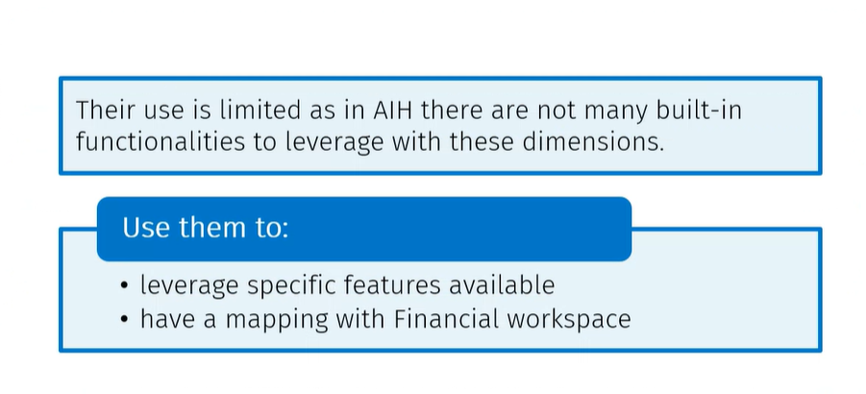
Use most of the time a Analytical dimension to replace it.
Category not always used.

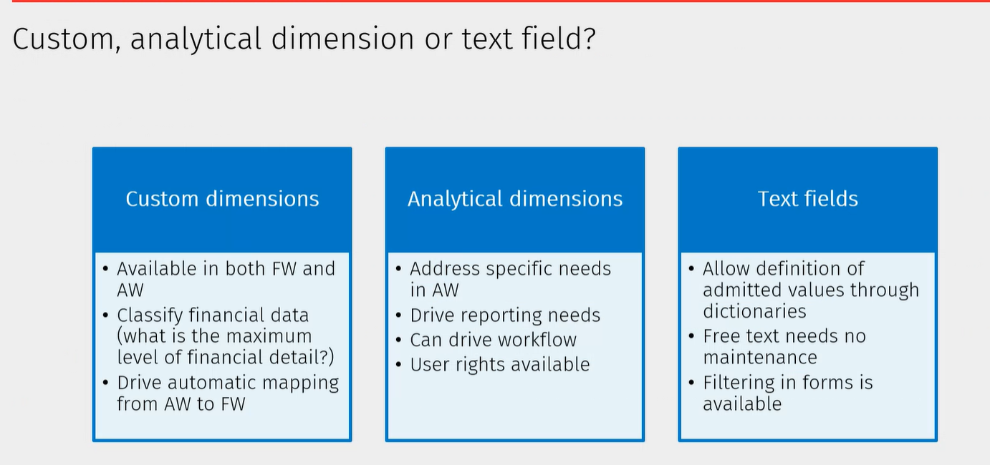
- Text fields : use when dealing with a definition that hardly needs a maintenance. A dimensions elmeents for which youd on’t want to create a dimension but just a dictyionaries

- Custom dimensions
- Analytical dimensions
Dimension representing hierarchy nodes :
- Use a secondary dimension, in which you copy the hierarchy. Allows to process quicker, than when using the normal hierarchy.
- The moment you starts calculating the DTP,…. You need to use a Datasource
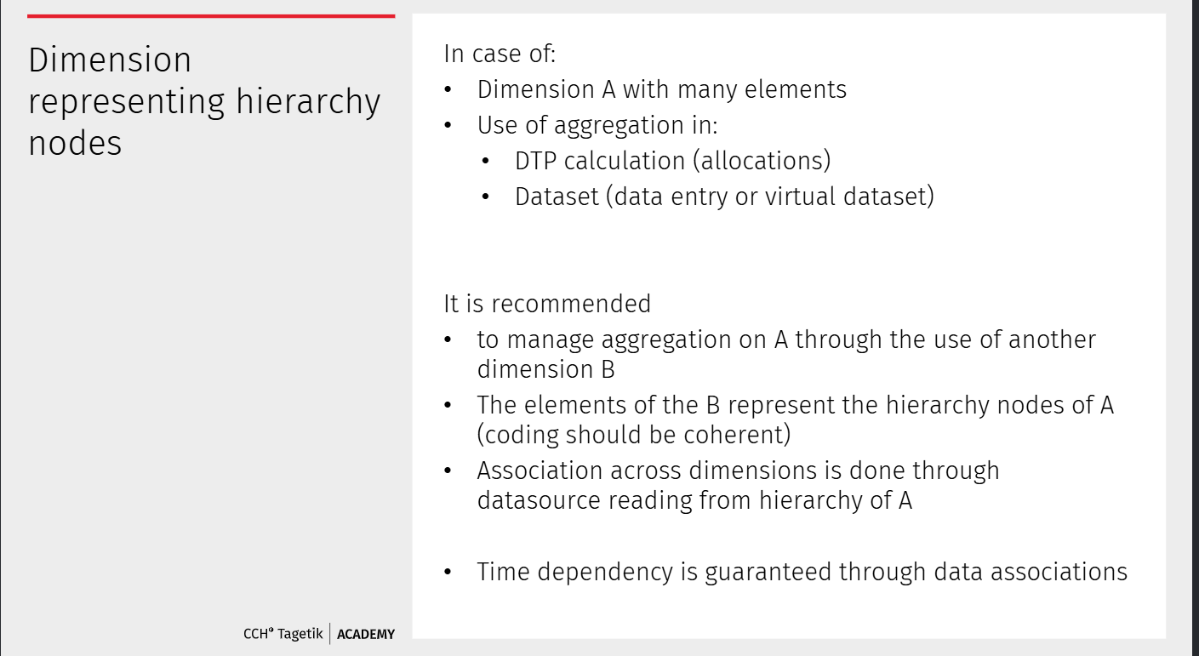
Out of dictionary value:

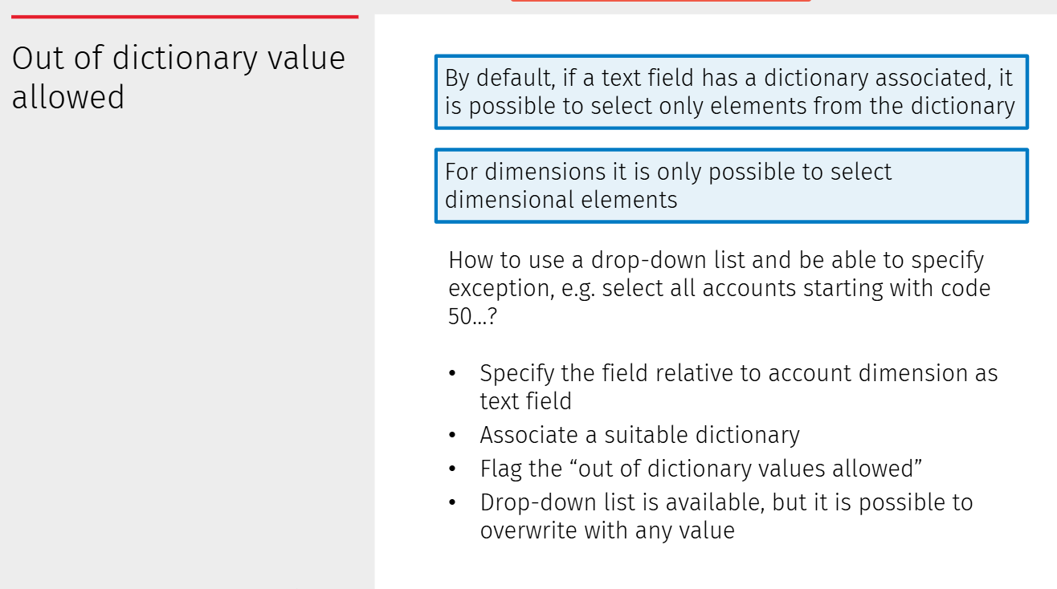

The down side of that, can have metadata that you don’t want to see.

Process :
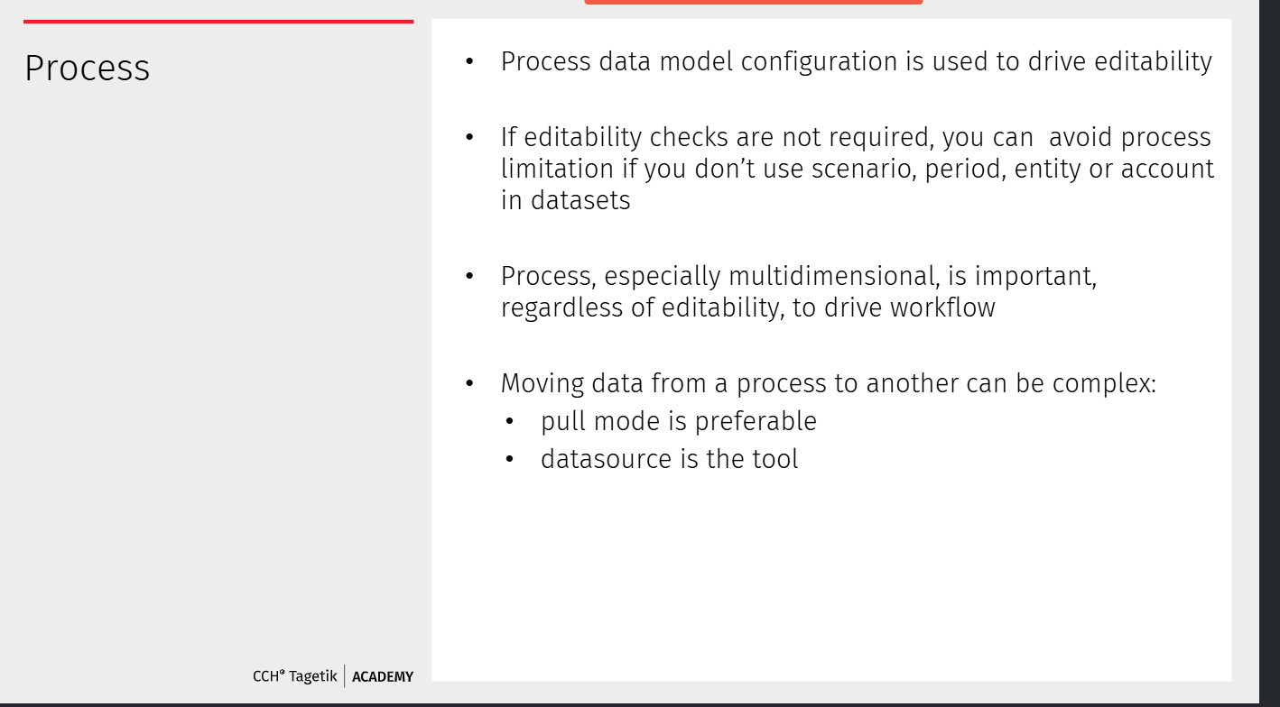

Calculations :
Dataset VS datasource :
- DTP is calculation tool

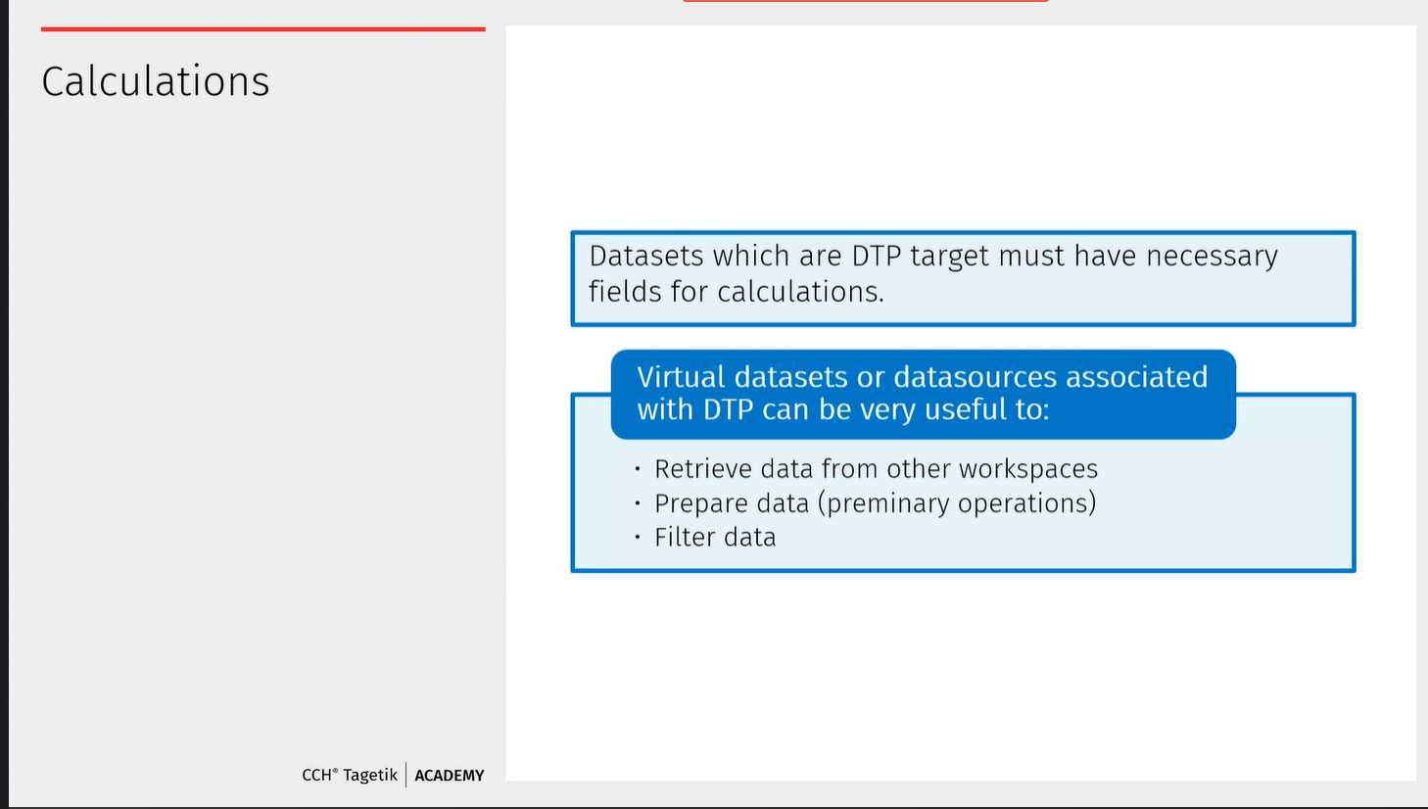
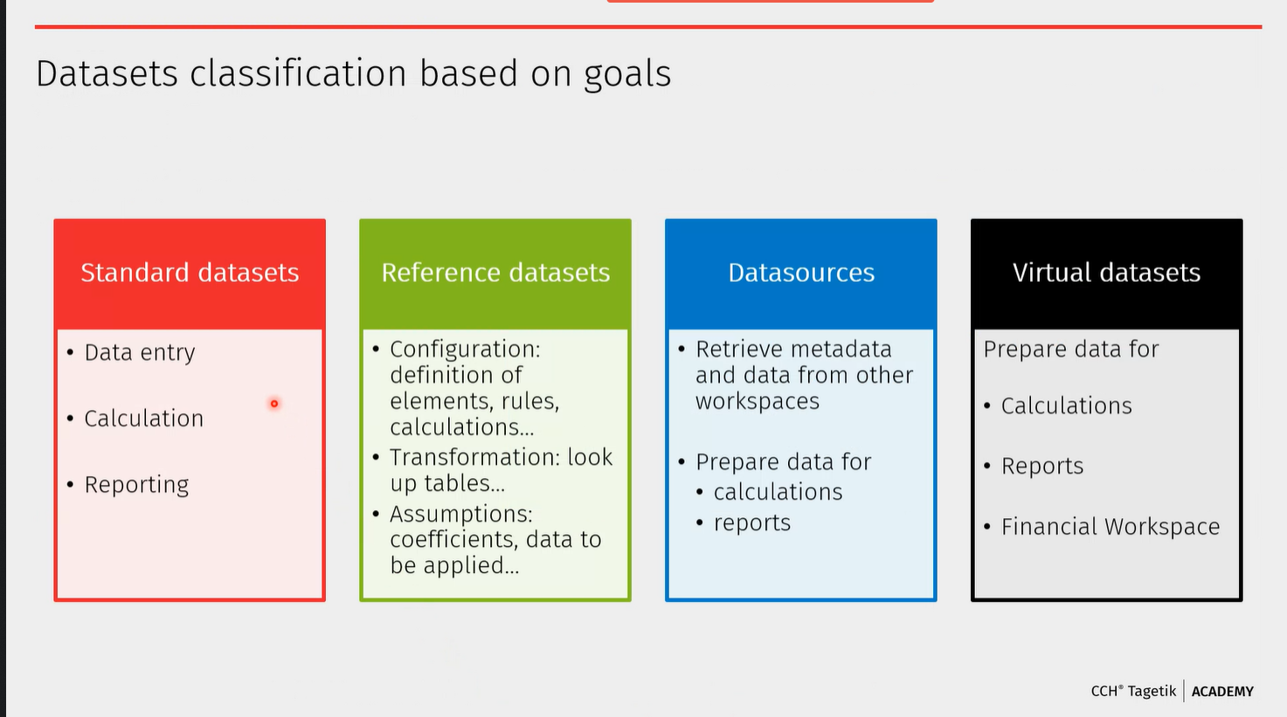

The reference dataset, are like lookup table in ETL: can also be used for assumptions.
- Datsource - retrieve data from other dataset and other AIH workspace and virtual datasets – Prepar your data for a DTP. Virtual dataset can only data from dataset in the workspace itself. It is a lot easier to use
- Reference datset, you don’t’ have creation limitations
- 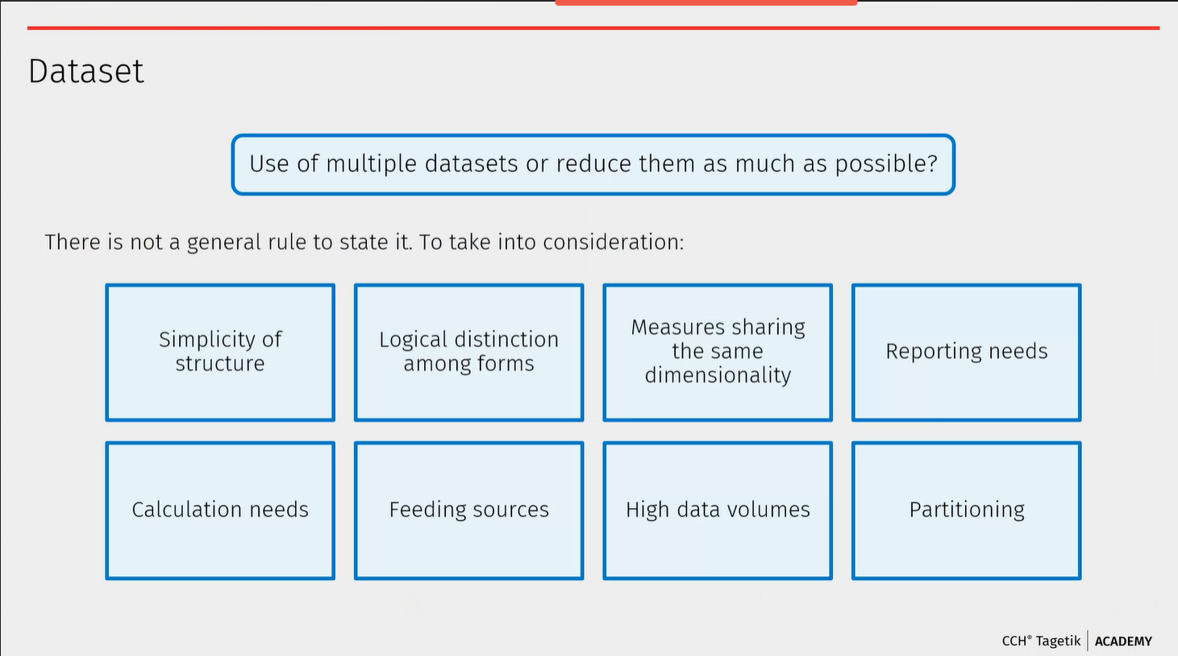
- There are no fixe rules when to create or not the dataset. :
- Forms can be a way to design the devision of datasets.
- Calculation needs can be a driver, if we need only to store the calculation data or report on it also
- High data volumes : Can have partitioning, can split the dataset, to keep the system performing.
Dataset ; fields
- 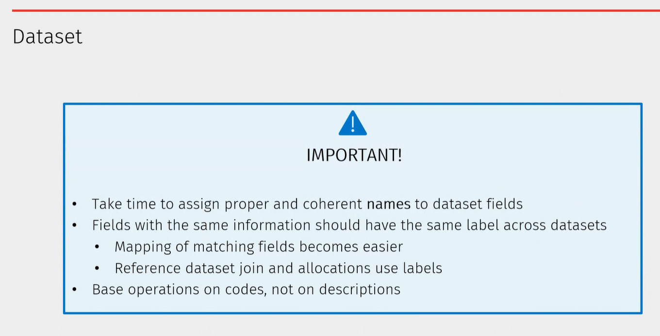
- Important to give proper name to the same naming conventions.
- Naming – some advice
- 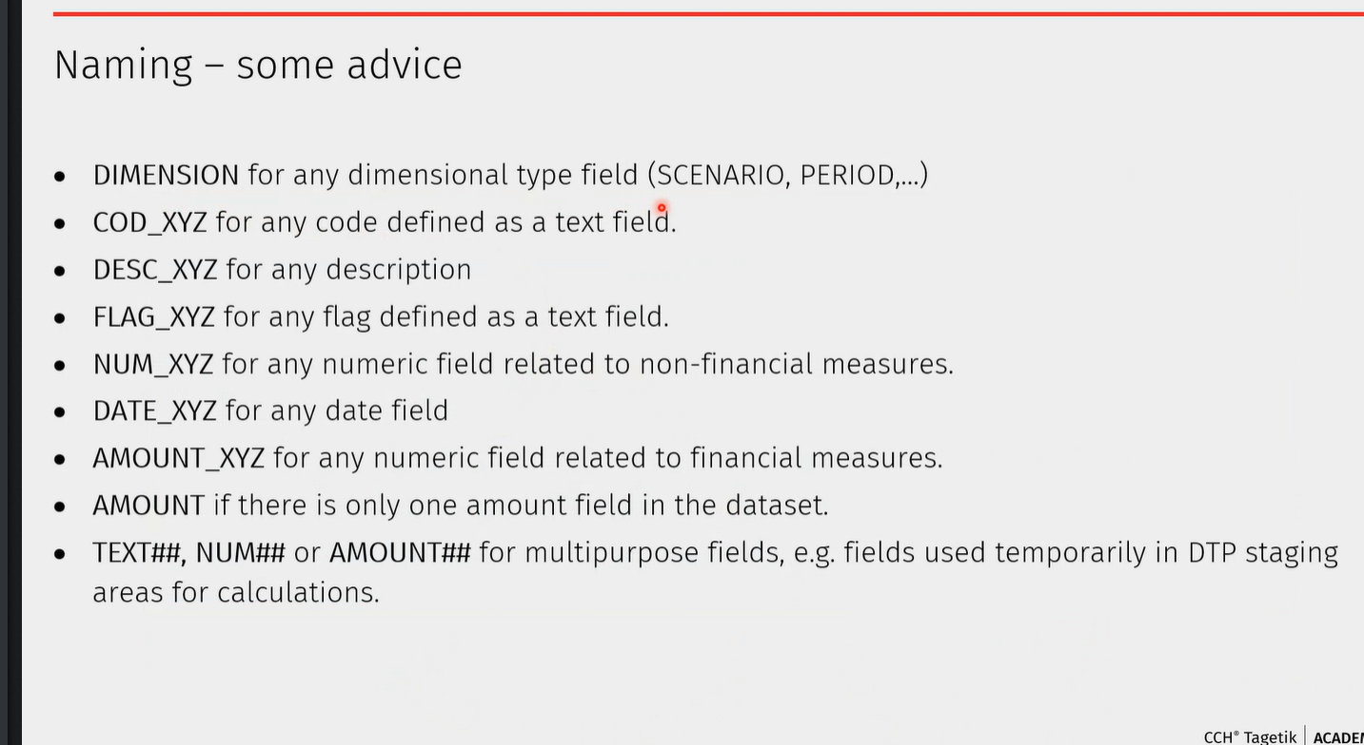
Virtual dataset : Useful when you have two small dataset, to have one big. Or if from one big dataset you only need a small part. It avoids the datastored > Avoid data processing
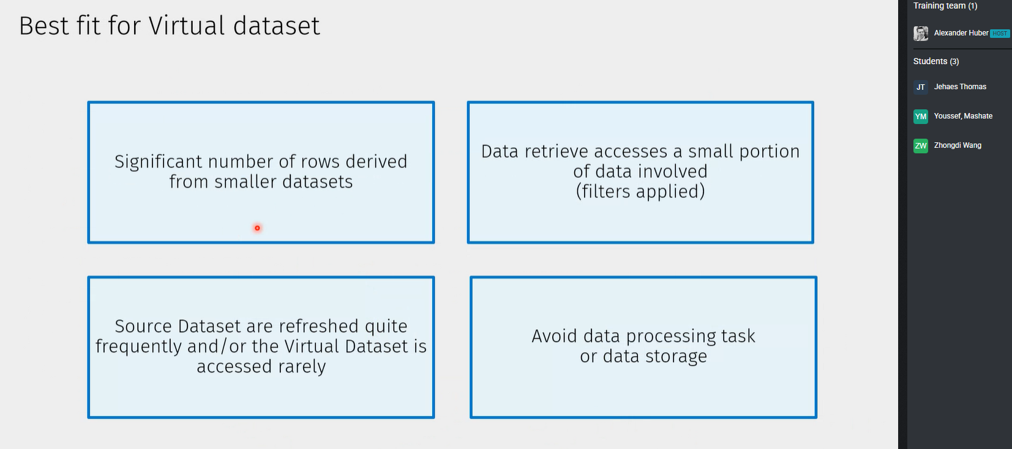
Datasource VS Virtual dataset :
- Use the virtual In a best way.
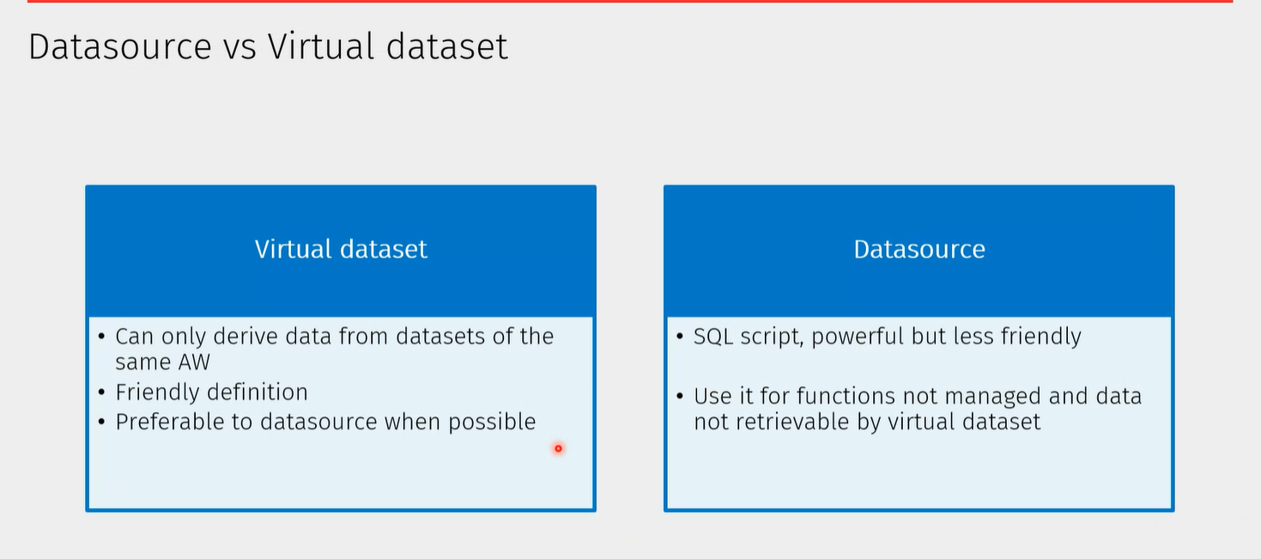

Datasource target :
- Use for reporting or for DTP preparation/extraction
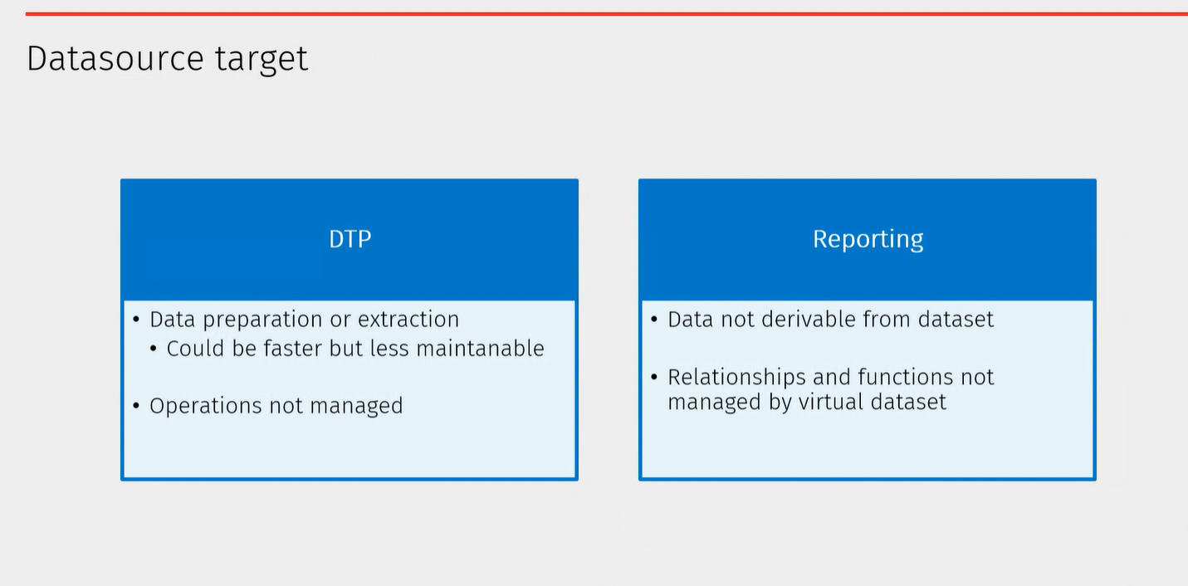

Question :
Top down budget : in the product families I have sub families, there in those nodes, I have elements into it. Will use the datasource

Discussion on solution to specific needs

Solution design workshops

Discussion on solution Design

Hands on exercises

Technical design guidelines

Filtering methods :
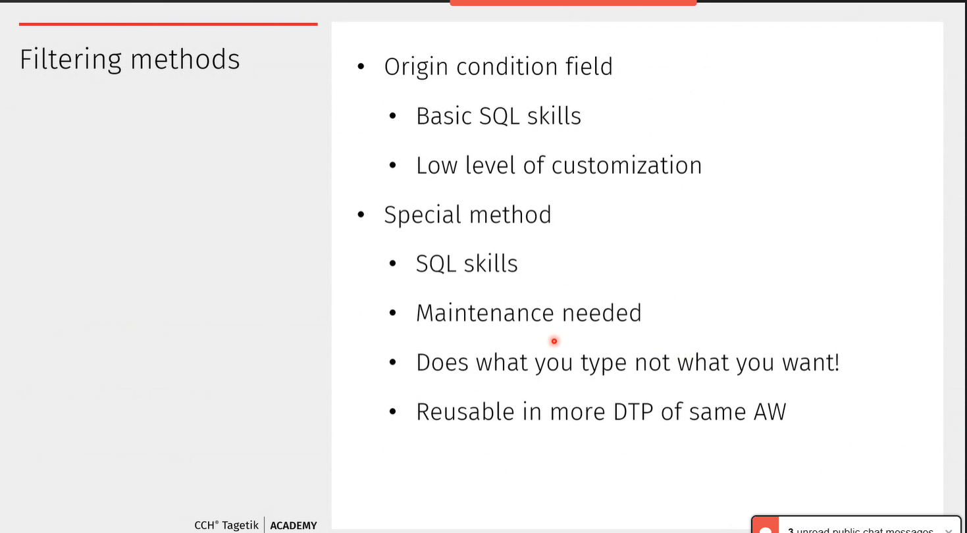
With the SP : the best is to make it reusable, using the parameters:
- Attributes in
- Use the reporting parameters
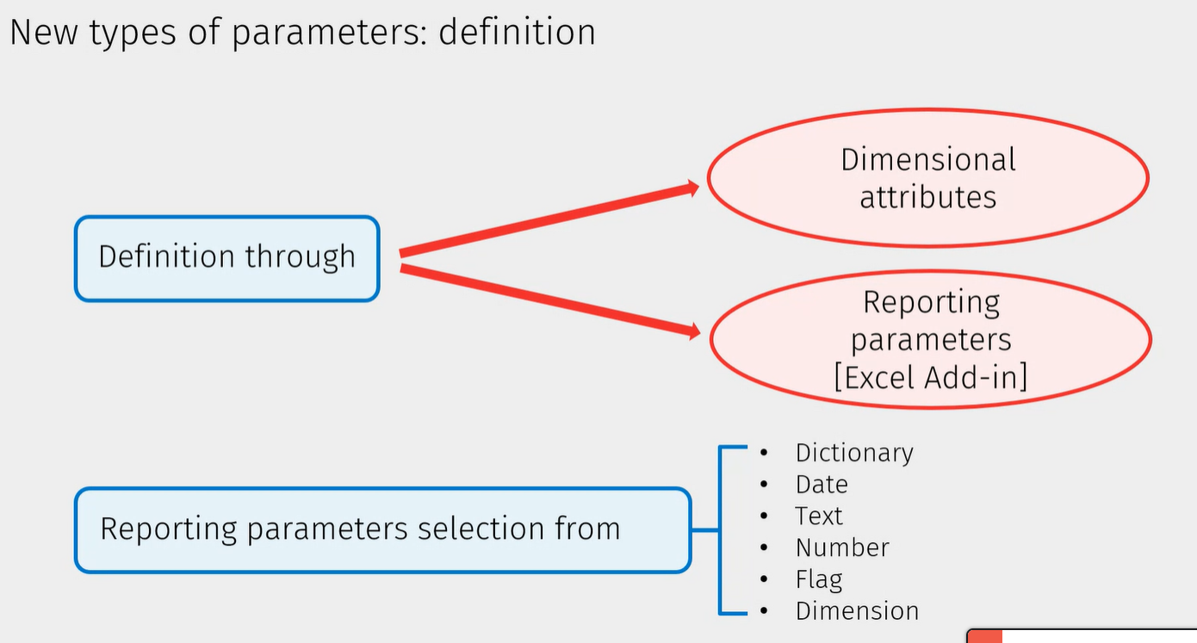
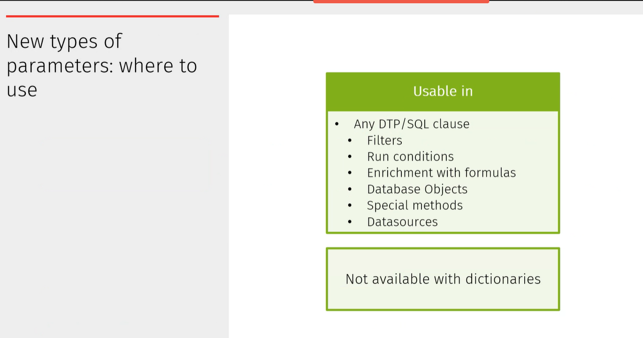

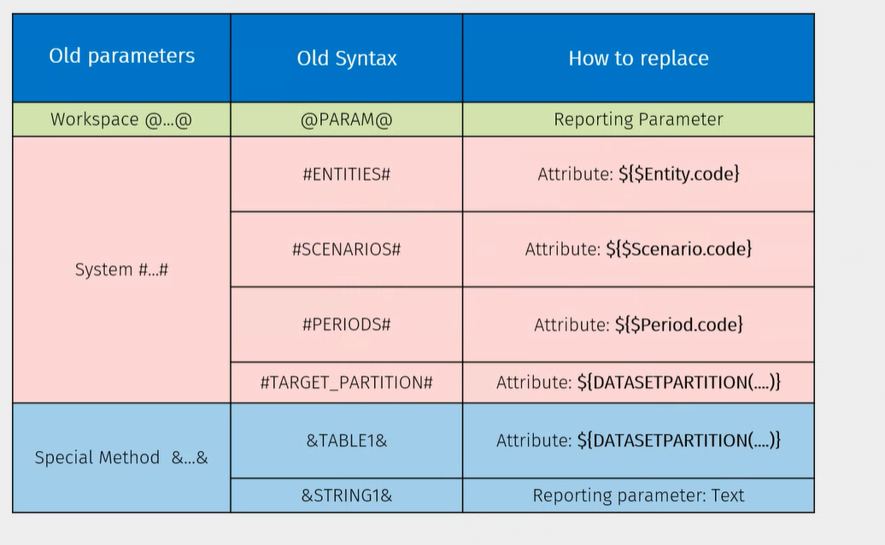

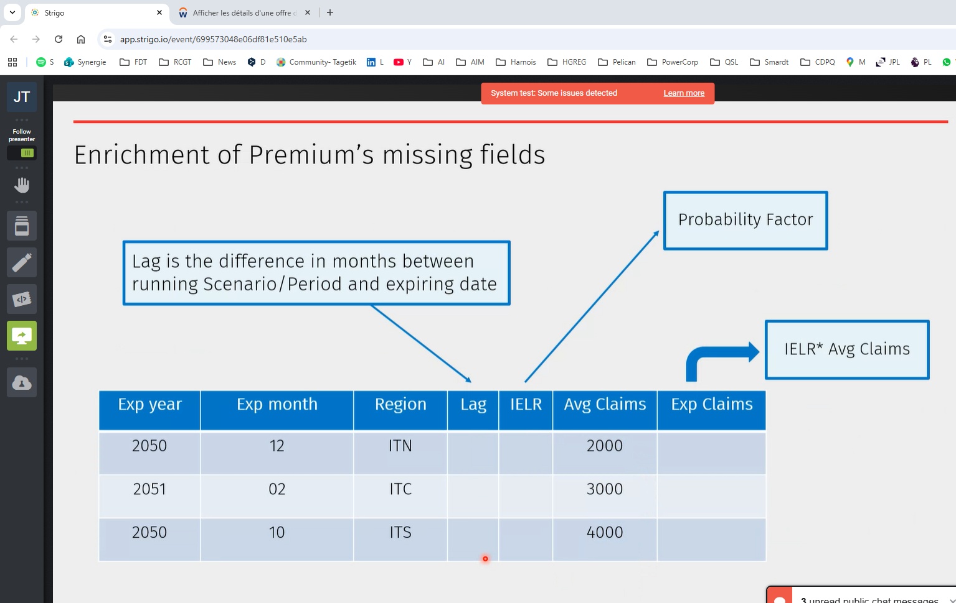

Insert with reference dataset : is like three operations in one :
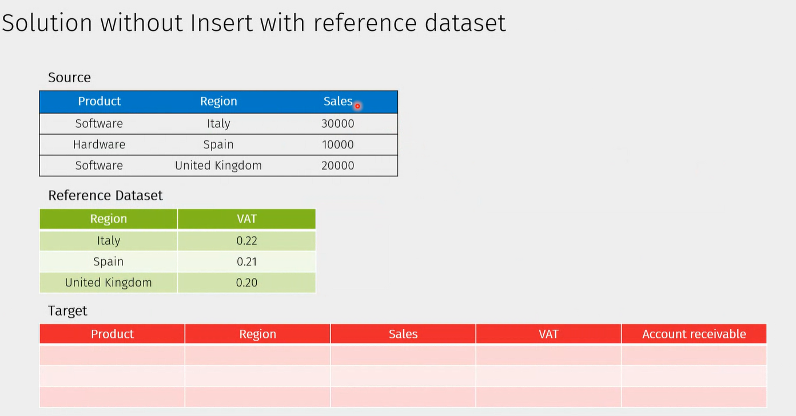

Allocation operation structure
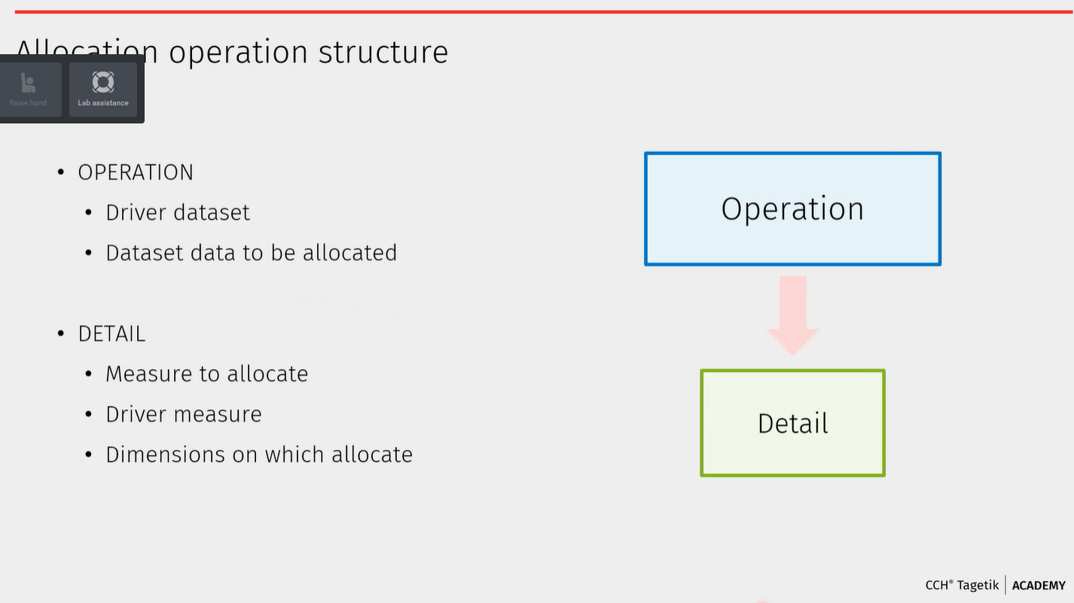

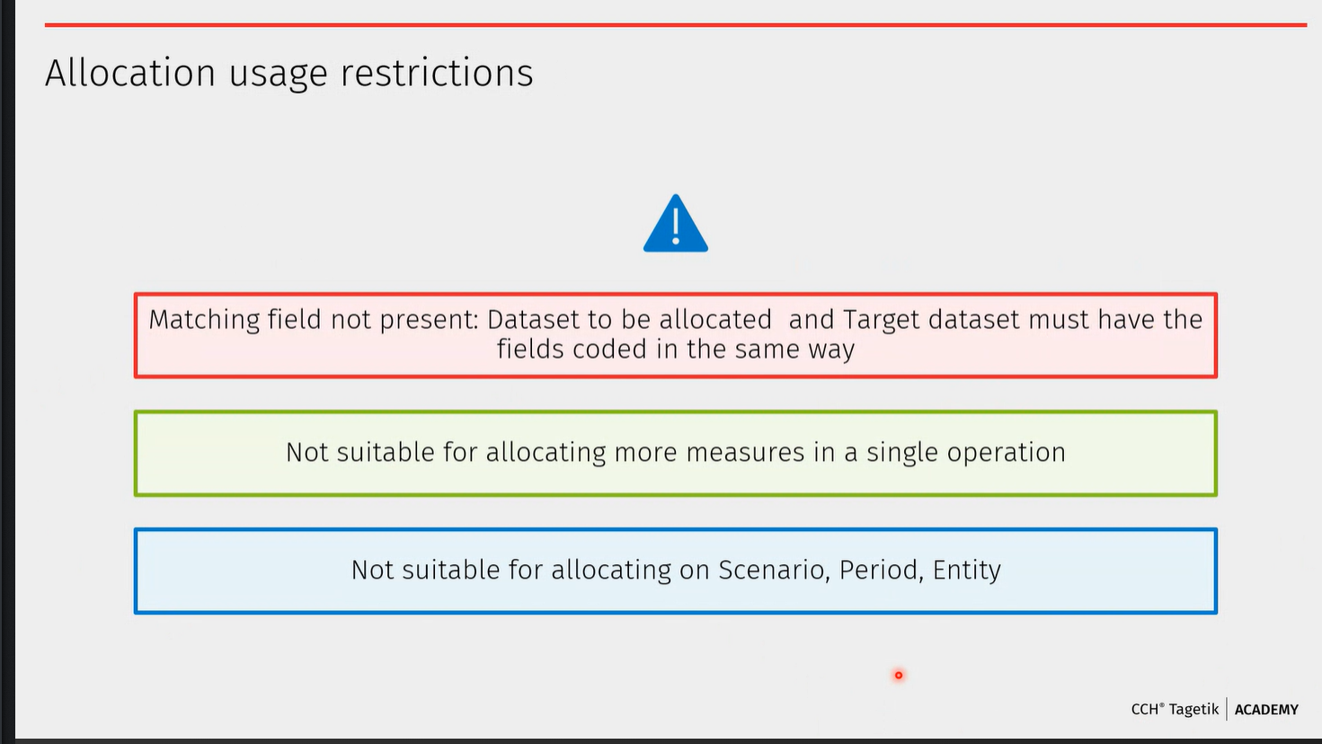
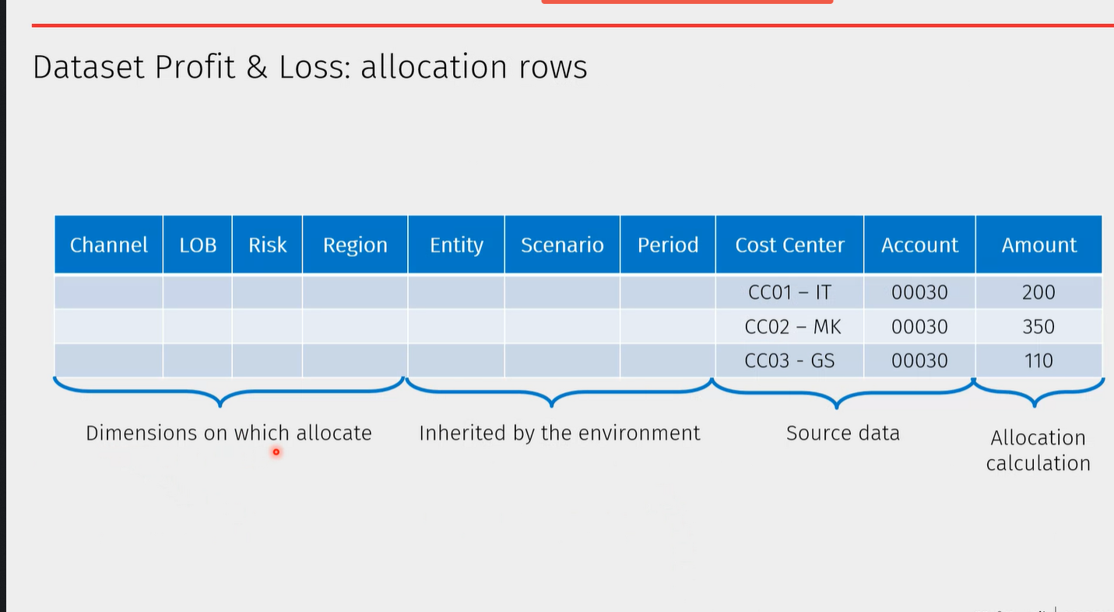

Why Technical perspective :
- The AIH : you are building a tool from scratch, require more technical knowledge.
- Only have guidelines no best practice
Dataset partitioning:
- None is only when you have a small amount of data
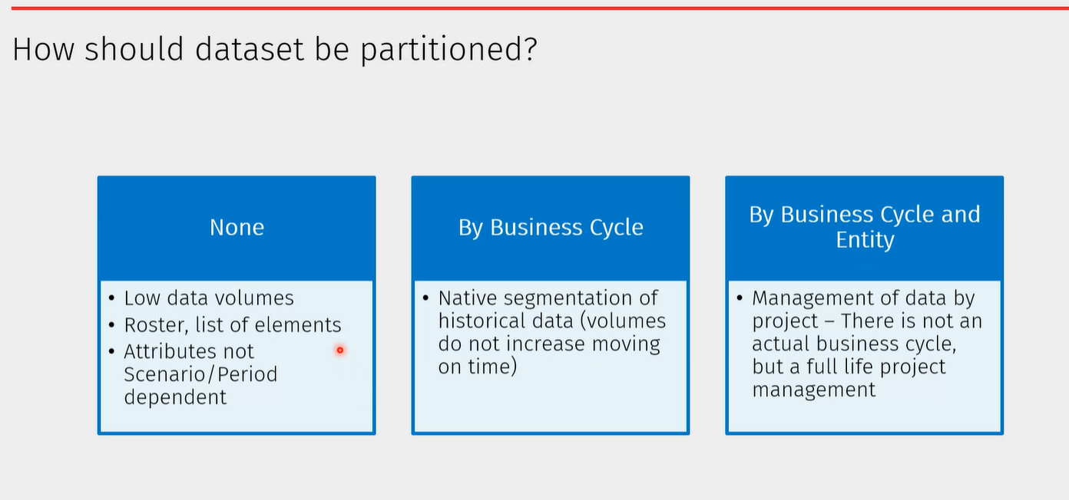
- By business Cycle and Entity: there is a lifetime cycle, no actual business cycle
- By business cycle
- Dataset portioning : The partition contains all and only data needed during each single request
- Partition contains only data of a single actual cycle
Have one process for one scenario : Better because of the partitioning.
Dataset Indexing:
- It will allow the system to quickly retriev the data you are looking for.
- IF have rows with rows # and cost centers.
- 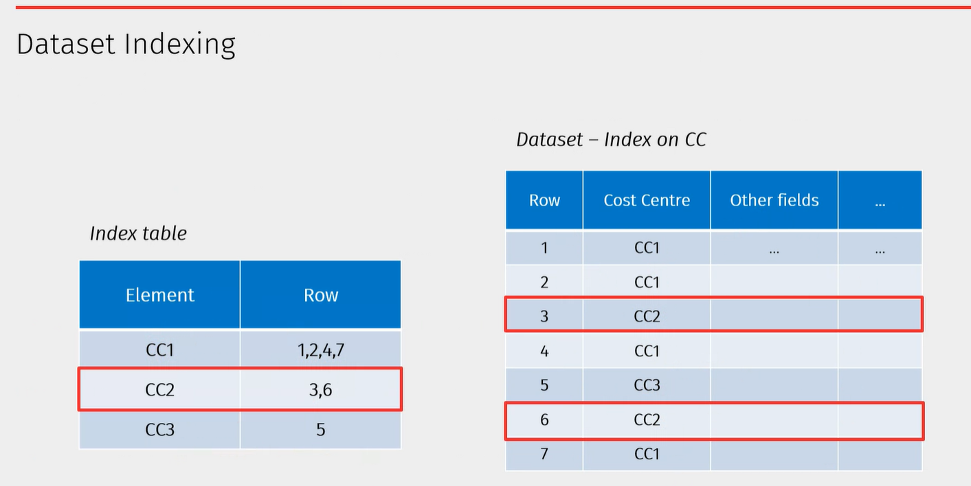 permit the system to find the data in a quicker way

- 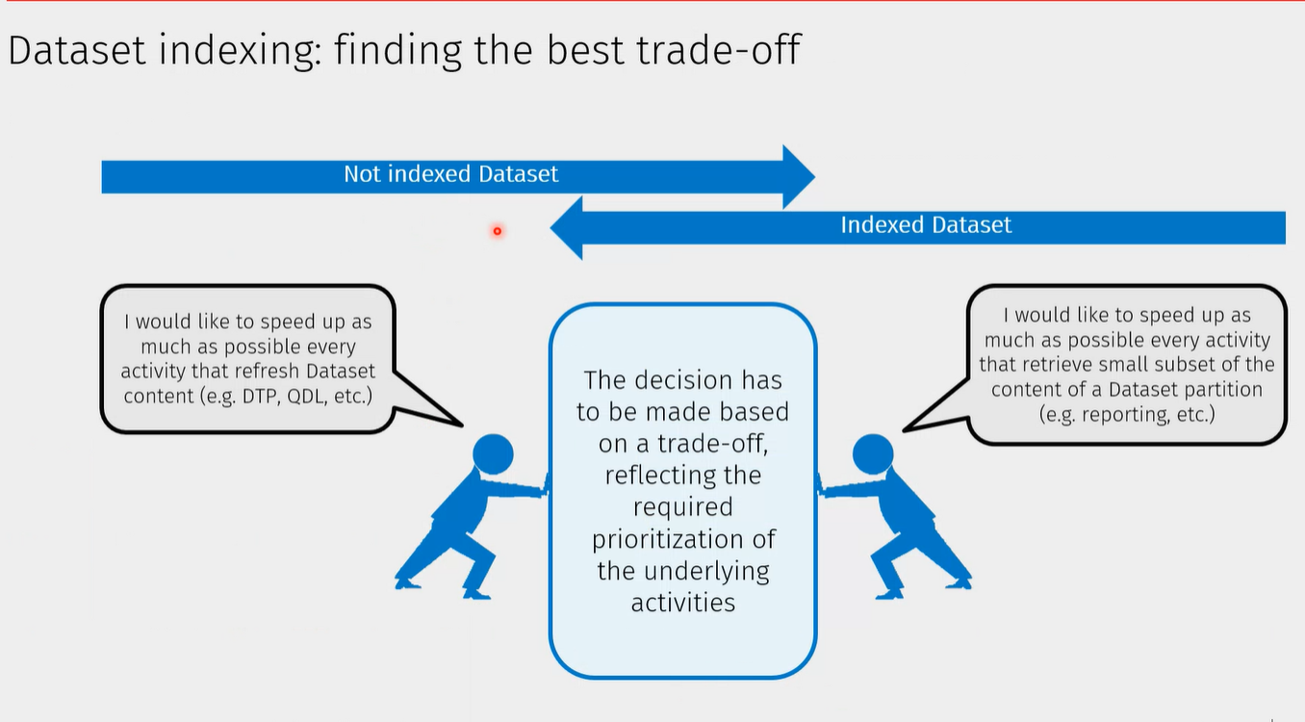
- Index dataset helps with the retrieval of data. It is going to be slower if have data entry.

DTP execution

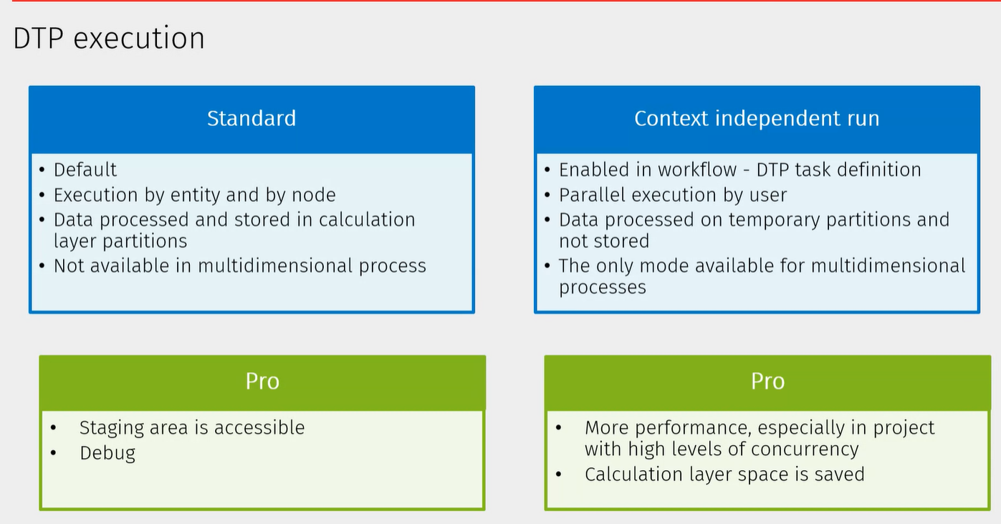

SAP Hana
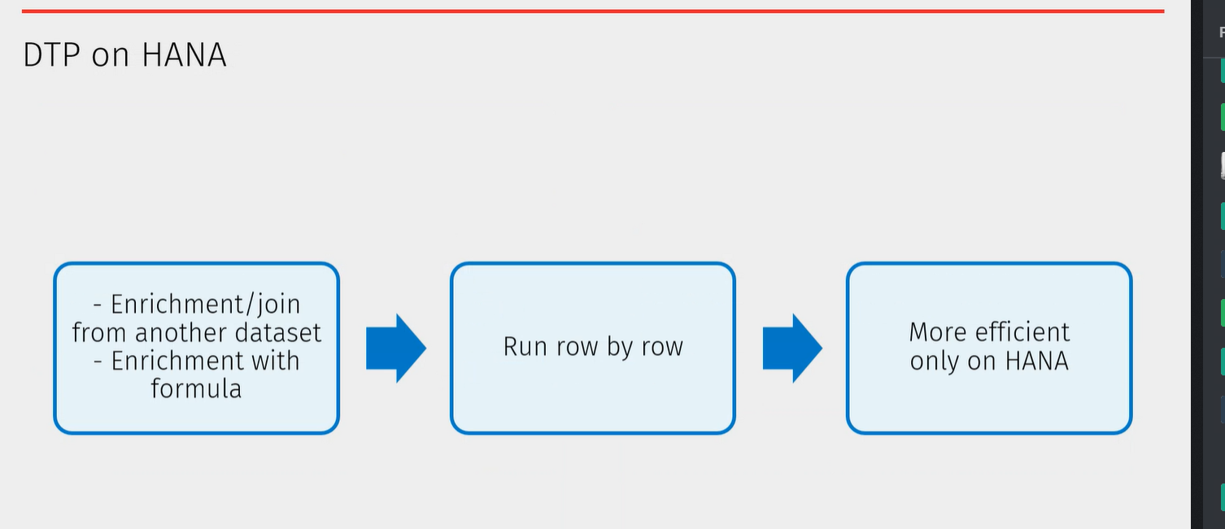
Enrichment/join or with formula, check row by row, will be more efficient.

Special method:


